Uwin Technologies Co., Ltd
Model:GA-3 Gloucose monitor
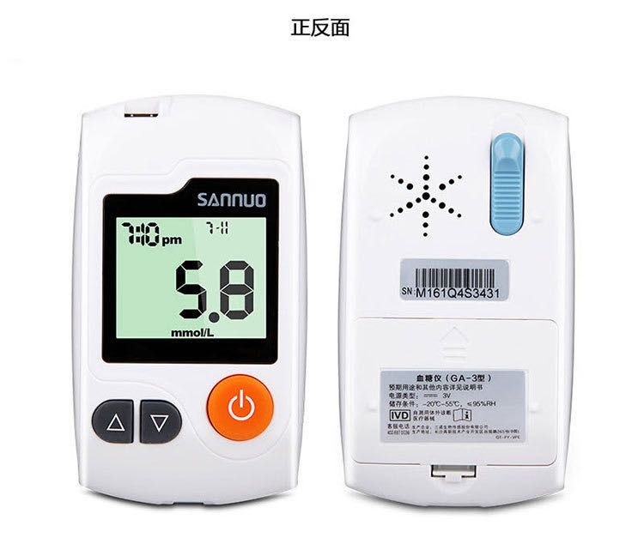

Features:
1. Blood sample: fresh peripheral whole blood, venous whole blood
2. Calibration sample: venous plasma
3. Blood volume: 0.6μl
4. Test range: 20-600mg/dL (1.1-33.3mmol/L)
5. Test time: 10s
6. Memory: 200 test results (average value of 7days/14days/28days)
7. HTC:30-60%
8. Operating Tamp Range:10-40C
9. Battery:2*AAA battery(not including)

