Uwin Technologies Co., Ltd
Model:LS600 SOUND BAR

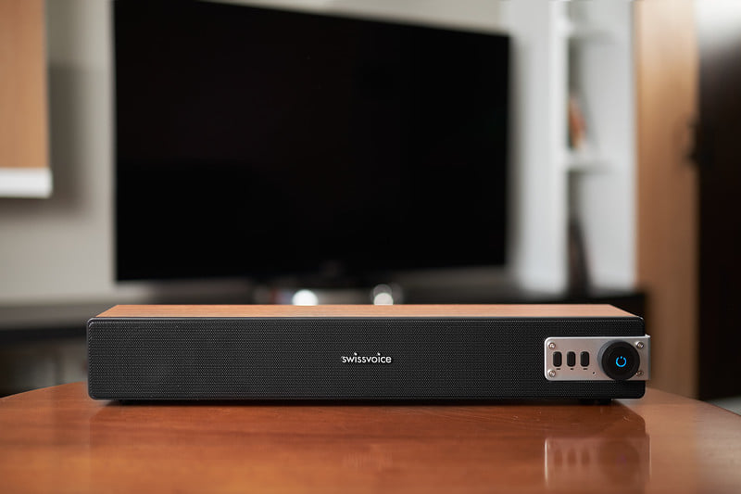

SPECIFICATION
1. OUTPUT POWER :5W X 2
2. UNIT SIZE :52MMX2+50X90MMX2 DIAPHRAGM
3. IMPENDANCE :4 Ohm
4. FREQUENCY RESPONSE :80HZ-18KHZ
5. DIMENSION :450L X 60W X50H MM
6. BLUETOOTH 5.0 VERSION
7.USB PLAYER BUILT IN
8.TF CARD READER BUILT IN
9.18650 LITHIUM BATTERY :3.7V. 2700mAh
10.AUX BUILT IN
11.USB POWER CHARGE
12.PLAY BACK 12 HOURS
13.FM Radio function

